Software Requirement Specification (SRS) for Organ
Donation And Finder Website

1. Purpose
The purpose of the Software Requirements Specification (SRS) for the organ donor and finder website is to provide a comprehensive and detailed document that defines what the website will do, how it should perform, and all the requirements that need to be fulfilled to meet the needs of its stakeholders. This document serves as a foundation and reference for all development, design, and testing activities, ensuring that the website effectively connects organ donors with recipients in a secure, reliable, and user-friendly manner.

2. Scope
The scope of this project is to develop a web-based platform that efficiently facilitates organ donation and transplantation by connecting prospective organ donors with patients in need. The website will:
- Enable online registration for both donors and recipients, including the secure collection of necessary medical information.
- Provide a matching system that automatically pairs donors and recipients based on medical compatibility, such as blood type, organ specificity, and urgency.
- Support verified medical professionals and hospital administrators in validating, monitoring, and updating donor/recipient profiles and status.
- Ensure secure, authenticated communication channels among donors, recipients, and medical staff.
- Generate notifications about new matches, status changes, and communication updates for all stakeholders.
- Maintain a high standard of data security, privacy, and compliance with all applicable legal and ethical regulations.

3. Benefits
- Quickly connects organ donors with recipients to save more lives
- Increases organ donation opportunities and awareness
- Provides secure and transparent communication between all users
- Streamlines coordination among donors, recipients, doctors, and hospitals
- Improves matching accuracy based on medical compatibility
- Offers hope and support to patients and donor families
- Ensures privacy and data security throughout the process

4. User Classes and Characteristics
- Donors: People willing to donate organs, either living or deceased, with specific medical and personal info.
- Recipients: Patients seeking organs, registered with details of their needs.
- Doctors: Professionals verifying data, approving matches, and overseeing transplants.
- Hospital Staff: Managing hospital data, organ inventory, and logistics.
- Admins: Managing system operations, user access, and data security.

5. System Features and Requirements

5.1. Functional Requirements
- Donor Registration: Allow individuals to create profiles as donors, including essential details and medical history. Data validation is required for medical accuracy.
- Recipient Registration: Enable those seeking transplants to sign up, specifying organ requirements and medical details.
- Matching Engine: Implement a search and match system considering compatibility (e.g., blood type, location, urgency), showing suitable donors to recipients.
- Communication: Provide secure messaging between donors, recipients, and medical professionals.
- Doctor Verification: Only verified doctors can add patient details and monitor transactions to prevent fraud.
- Notifications: Inform users about status updates, new matches, and relevant communications.
- Document Upload: Allow doctors and patients to upload medical certificates and records for verification.

5.2. Non-Functional Requirements
- Security: Ensure all data is encrypted, access is authenticated, and privacy is maintained.
- Performance: Rapid search and matching functions (e.g., 95% of results < 2 seconds).
- Reliability: Data integrity is critical; the system should be robust and fault tolerant.
- Usability: Interfaces must be user-friendly and accessible.
- Compliance: Adhere to medical and legal standards for organ donation.

5.3. External Interface Requirements
- Database: Store donor, recipient, and transaction records securely.
- Hospital Integration: Connect with verified external systems for realtime data syncing.
- User Roles: Define distinct permissions for donors, recipients, doctors, and administrators.

6. System Model

6.1 Use Case Diagram
- Actors: Donor, Recipient, Doctor, Hospital Staff, Administrator
- Use Cases: Register, Login, Update Profile, Search Matches, Match Donor and Recipient, Upload Documents, Verify Data, Communicate, Receive Notifications, Manage Users.
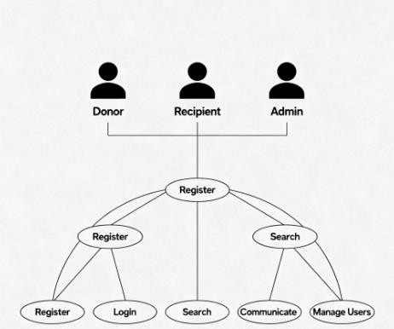

6.2 Data Flow Diagram (DFD)
- Level 0: Donor/Recipient/Admin interacts with Organ Donation System → Database updates and queries occur.
- 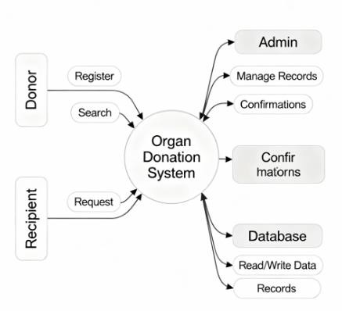
- Level 1: Registration Management, Match Searching,
Communication Handling, Document Verification, User Management 6.3. Entity Relationship Diagram

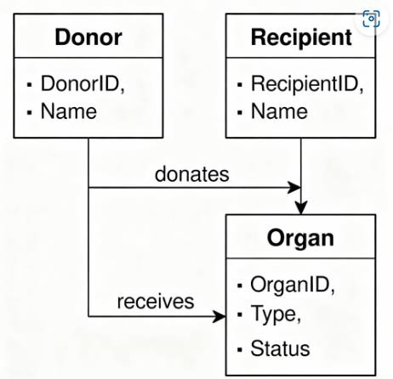

7. Appendix
Future Scope: Expand with AI-based matching, blockchain security, and global healthcare integration.
Limitations: Dependent on internet, regulatory challenges, and limited user awareness.

